Date: 29.04.2026
Declaration

A total of four (04) students secured letter marks in Anthropology in the HS Final Examination, 2026.

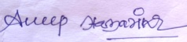
Dr. Anup Hazarika
HoD., Anthropology Department
North Gauhati College.

