THREE MONTHS CERTIFICATE COURSE (Add on) ON REMOTE SENSING, GPS AND GIS APPLICATION
BY Department of Geography, North Gauhati College

Department of Geography conducted a Certificate Course (Add on) ON REMOTE SENSING, GPS AND GIS APPLICATION for three (3) months duration. The course was started on 19.04.2022 by an Inaugural session in the Department of Geography. The Vice Principal of North Gauhati College Dr. Sumanjit Kakati inaugurated the certificate course for the students. Total 13 students were enrolled and admitted in the course. The Course included both theory and Practical classes and completed on 19.07.2022.
The syllabus of the Course was prepared with the following components.
Unit 1 (Remote Sensing)
- Introduction to Remote Sensing
- Components of Remote Sensing :
a. Energy sources,
b. EMR and its interaction with Atmosphere and Earth Features;
c. Senor carrying Platforms,
d. Sensors;
e. Targets
- Types of Remote Sensing : Aerial and Satellite Remote Sensing;
- Visual Image Interpretation techniques
- Digital Image Processing: Image Enhancement and Classification (Supervised and Un-supervised).
4. Application of Remote Sensing: Land, Vegetation and Water
Unit 2 (GIS)
- Geographical Information System (GIS):
- Development and Functions of GIS Components
- Open source GIS
- GIS Data Types
- Spatial and Non-Spatial Data
- Raster and Vector Data
- Database Management System (DBMS)
- Data Layer Extraction and Spatial Analysis:
- Buffer, proximity and overlay analysis.
- Application of GIS in geographical studies (Land Suitability analysis, Network analysis, Flood damage estimation)
Unit 3 (GPS)
- Global Positioning System (GPS):
- Basic principles and functions of GPS;
- Different Navigational Systems of GPS.
- Application of GPS in surveying and mapping

Hand on Practices

1. Visual Interpretation of Aerial photograph and Satellite Imagery and preparation of thematic maps based on appropriate classification scheme.
- Analysis of aerial photographs and satellite image: Determination of photo scale and object height from aerial photo (Using Sterescope);
- Digital classification of satellite image: supervised and unsupervised.
- Geo-referencing and Data layer creation: Map scanning, geometric correction
- Digitization of different layers using point, line and polygon, attribute data input and their thematic representation, Buffer creation, Overlay analysis.
- GPS data collection, plotting and mapping of various features
- Image to Image rectification
- Downloading Satellite images and toposheets
- Delineation of drainage basin and basin network and morphometric analysis using GIS -to final map design and layout
- Google Earth
- Land use and Land cover mapping, NDVI. ( Supervised and Unsupervised classification)
- Hazard Zonation mapping (QGIS)

Different classes were taken by different Resource Persons invited from other institutions. They are Dr.Biman Lahkar, B. P. Chaliha College, Dr.Dhanjit Deka, Gauhati University, Dr. Krishna Das, Pragjyotish College, Dr. Chandra Kant Pawe, Pragjyotish College, Binod Kumar Nath, Directorate of Border Protection and Development Department, Assam. Besides , the faculties form Department of Geography , North Gauhati College namely, Bulen Kakati, Dr. Sujata Deori, Dr.Purabi Hazarika, and Dr. Lekha Borah also were the resource persons in the course.
Dr. Biman Lahkar taught the students about Georeferencing, Digitizing Buffer, Overlay Analysis, and Digital Image Processesing. Binod Kumar Nath taught the students about Datalayer Extraction and Point Analysis: Proximity, Buffer, Overlay analysis. Dr. Krishna Das included in his topics: downloading of Toposheets and Satellite Imageries, how to work with QGIS , Layer stocking and clipping, QGIS map layout, NDVI & NDVI in QGIS , River bank line shifting in QGIS , Hazard zonation in QGIS. Dr. Dhanjit Deka taught the students about Database Management System, Drainage basin delineation and stream ordering from DEM. Dr.Chandra Knt. Pawe taught the students about Digital Image classification and Land use Land cover mapping, determination of Photoscale and Object height with the help of Stereoscope.
Bulen Kakati included the concept of Remote Sensing and it’s application in his classes. Dr.Sujata Deori taught about what is Remote Sensing: Concept, Definition, Natural and Artificial Remote Sensing, Components of Remote Sensing, EMR , Atmosphere and types of Satellites. She also taught about the Global Positioning System (GPS) in both Theory and Practical classes. Dr.Purabi Hazarika taught about choropleth mapping, dot map, Density map, Spatial variation by Pie and Bar diagrams. Dr. Lekha Borah taught the students about Aerial and Satellite Remote Sensing.
At the end of the Course a Course End Test was held on 26.09.2022. The students appeared both in theory and Practical tests. The result was declared on 28.09.2022 and Deepsikha Boro stood on the first position. Harshita Bharali and Sibani Borah jointly stood on the second position and Manashi Das achieved the 3rd position in the Course End Test.
A warm Valedictory Function was held on 29.09.2022 at the Conference Room, North Gauhati College where Dr. Kalyanjit Sarmah, Senior Project Scientist, Assam State Space Application Centre (ASSAC), Bigyan Bhawan, Guwahati delivered a fruitful lecture cum LCD presentation on Use and Application of Remote Sensing Techniques and GIS.

Sample of Invitation letter to Resource Person

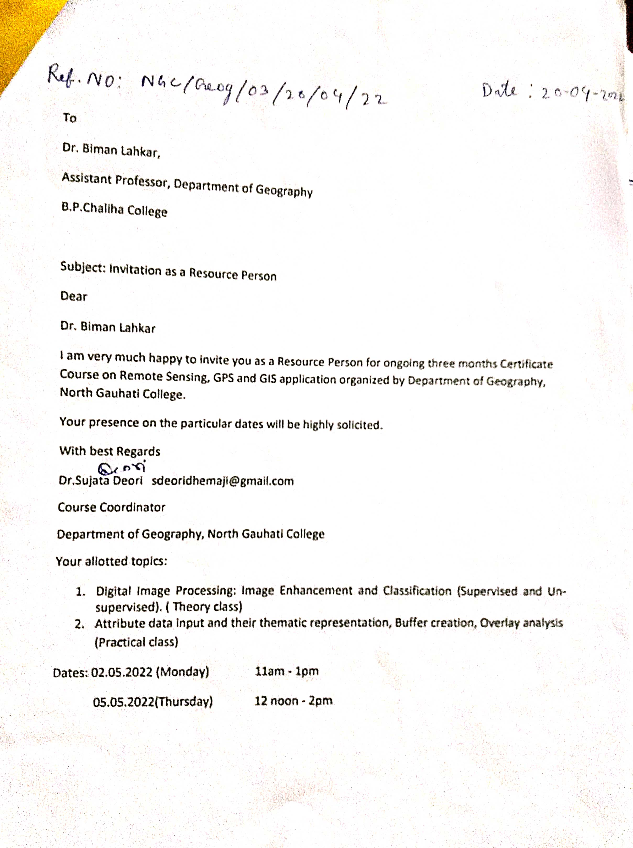
Sample of Invitation letter to the Chief Guest for the valedictory function

