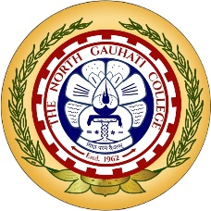**DEPARTMENT OF POLITICAL SCIENCE**

NORTH GAUHATI COLLEGE

College Nagar

Guwahati - 781031

**INVITATION**

Dear Parents,

The Department of Political Science, North Gauhati College is pleased to invite you to the Parent-Teacher Meeting 2025 for the parents of the present 3rd and 5th semester (only major) students. This meeting aims to identify areas of improvement, foster a collaborative partnership between parents and teachers to support the student’s holistic and academic development and discuss planning for better results for the students in the current academic year.

Your presence is highly appreciated as we work together for the success of our students.

Day: **Saturday**

Date: **6th September 2025**

Time: **10:00 AM -11 AM**

Venue: **Room No. 2**, **Department of Political Science**

Best Regards,

**Department of Political Science, North Gauhati College**